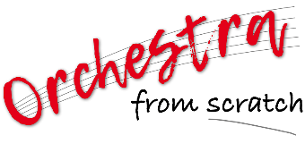
ORCHESTRA FROM SCRATCH

Open to anyone who can read & play music – minimum Grade 3

PROGRAMME | A massed orchestra performing prescribed music conducted by SUSAN CØCK
VENUE | Examination Hall, Wits Education Campus, Parktown.  Near the Linder Auditorium
DATE | Sunday 28 January, 2024
REHEARSALS | Saturday 14:00 - 16:00  Sunday 11:00 - 14:00
MAIN CONCERT | Sunday 15:00 - 16:00
ENTRY FEE | R40.00 per person (includes one complimentary audience ticket)
CLOSING DATE FOR ENTRIES | 10th January 2024
AUDIENCE TICKETS | R30 (available at the door)
MUSICIAN DRESS | Smart Casual: bright colours (NOT black & white!)

RULES OF ENTRY
All participants must register to play either as individuals or as part of a group. An entry fee of R40.00 per person applies.

It is expected that all participants will be fully conversant with the prescribed music. Participants are encouraged to be thoroughly prepared and rehearsed in order to ensure that the concert will be a successful team effort – this concert can be an amazing experience for all involved if everybody performs at their best.

MUSIC KITS
Once musicians have registered and paid their entry fee, music kits with the specified parts will be given to the players.

VERY IMPORTANT
Participants are required to bring their own MUSIC STANDS, PENCILS & MUSIC SCORES on the day of the concert.

LUNCH
Please bring your own lunch and refreshments.

PROPOSED PROGRAMME:

To be confirmed
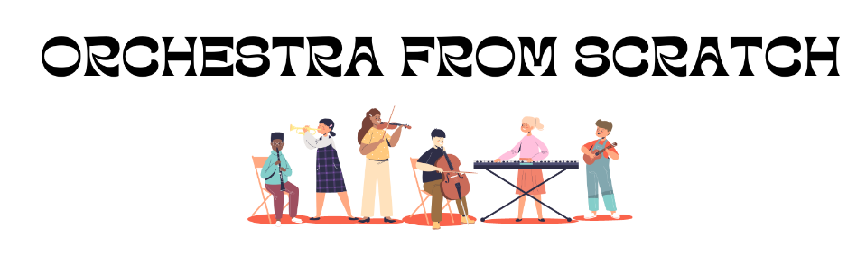
FOR FURTHER INFORMATION

PHONE: 074 850 9916 E-MAIL: richardcockmusic@gmail.com

OFFICE USE ONLY

R 40: PAID / TO PAY
MUSIC TAKEN: YES / NO
REGISTRATION FORM

JOHANNESBURG INTERNATIONAL MOZART FESTIVAL
Sunday, 28th January 2024 11:00 – 16:00

CLOSING DATE FOR ENTRIES: 10th January 2024

PLEASE COMPLETE ALL DETAILS BELOW CLEARLY IN BLOCK LETTERS

FULL NAME………………………………………………………………………………………………

CELL No…………………………………………… PHONE No……………………………………

E-MAIL ADDRESS: ……………………………………………………………………………………

INSTRUMENT: ………………………………………………

ABILITY (1st, 2nd Player): ………………………………………

FEE: R40.00 EFT payable to: Apollo Music Trust

BANK DETAILS: NEDBANK Greenside (197505) 1975 046 889.
Reference: OFS Your Surname
Please email payment confirmation to richardcockmusic@gmail.com

SIGNATURE: ………………………………………………………………………………………………

RETURN TO: richardcockmusic@gmail.com ♫

COLLECT MUSIC: From: 4th December 2023 onwards (Office closed: 11 Dec 2023 – 8 Jan 2024)
At: 15 10th Street, Parkhurst, Johannesburg (closest corner 4th avenue/10th street) OR the music can be scanned and sent by email.

